**Week 8**

**Airline Flight Database**

create table flights(

fl_no int primary key,

from_ varchar(20),

to_ varchar(20),

distance int,

departs time,

arrives time,

price int

);

create table aircraft(

a_id int primary key,

a_name varchar(20),

cruising_Range int

);

create table employee(

e_id int primary key,

e_name varchar(20),

salary int

);

create table certified(

e_id int,

a_id int,

FOREIGN KEY(e_id) REFERENCES employee(e_id) on update cascade on delete cascade,

FOREIGN KEY(a_id) REFERENCES aircraft(a_id) on update cascade on delete cascade

);

insert into employee values(101,'Avinash',50000)(102,'Lokesh',60000),

(103,'Rakesh',70000),

(104,'Santhosh',82000),

(105,'Tilak',5000);

insert into aircraft values(1,'Airbus',2000),

(2,'Boeing',700),

(3,'JetAirways',550),

(4,'Indigo',5000),

(5,'Boeing',4500),

(6,'Airbus',2200);

insert into certified values(101,2),

(101,4),

(101,5),

(101,6),

(102,1),

(102,3),

(102,5),

(103,2),

(103,3),

(103,5),

(103,6),

(104,6),

(104,1),

(104,3),

(105,3);

insert into flights values(1,'Bengaluru','NewDelhi',500,'06:00','09:00',5000),

(2,'Bengaluru','Chennai',300,'07:00','08:30',3000),

(3,'Trivandrum','NewDelhi',800,'08:00','11:30',6000),

(4,'Bengaluru','Frankfurt',10000,'06:00','23:30',50000),

(5,'Kolkata','NewDelhi',2400,'11:00','03:30',9000),

(6,'Bengaluru','Frankfurt',8000,'09:00','23:00',40000);

**To Do:**

1. **Find the names of aircraft such that all pilots certified to operate them have salaries more than Rs.80,000.**

Query:

select (a.a_name) from employee e inner join certified c

on e.e_id=c.e_id and e.salary>80000 inner join aircraft a on

a.a_id=c.a_id;

Output:

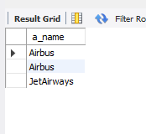

1. **For each pilot who is certified for more than three aircrafts, find the eid and the maximum cruising range of the aircraft for which she or he is certified.**

Query:

select c.e_id, max(a.cruising_Range) as Max_Range

from aircraft a, certified c

where c.a_id=a.a_id group by c.e_id having count(*)>=3;

Output:

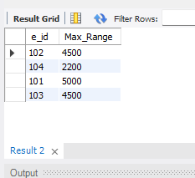

1. **Find the names of pilots whose salary is less than the price of the cheapest route from Bengaluru to Frankfurt.**

Query:

select e_name from employee where salary<any(select price

from flights where from_='Bengaluru' and to_='Frankfurt');

Output:

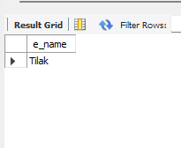

1. **For all aircraft with cruising range over 1000 Kms, find the name of the aircraft and the average salary of all pilots certified for this aircraft.**

Query:

select c.a_id,a.a_name, AVG(e.salary) from certified c, aircraft a,

employee e where a.cruising_Range>1000 and e.e_id=c.e_id and

a.a_id=c.a_id group by c.a_id;

Output:

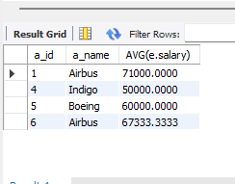

1. **Find the names of pilots certified for some Boeing aircraft.**

Query:

select distinct e.e_name from employee e, certified c, aircraft a

where a.a_id=c.a_id and e.e_id=c.e_id and a.a_name='Boeing';

Output:

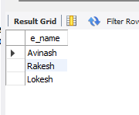

1. **Find the aids of all aircraft that can be used on routes from Bengaluru to New Delhi.**

Query:

select a.a_id from flights f, aircraft a where (f.from_='Bengaluru'

and f.to_='NewDelhi') and f.distance<=a.cruising_Range ;

Output:

